**Supplemental Information: Anticipating anthropogenic threats in acquiring new protected areas**

[Blinded for review]

# PLANNING PROBLEM

Each planner operates in a landscape divided into discrete sites, indexed by *i*, with *j* species across the landscape, where the species in each site is denoted by *aij*, and with each site posing different purchase and enforcement costs, denoted by $c_{x_{i}}$ and $c_{w_{i}}$ respectively. Following classic reserve site selection frameworks, all species outside of protected areas are assumed not to persist and contribute no value to the landscape’s expected species conservation for the 3 planners explored here (Ando et al. 1998). The planner makes a maximum of two choices about each site *i*: designate a protected area (*xi* = 1) or not (*xi* = 0), and enforce against human threats in a protected area (*wi* = 1) or not (*wi* = 0).

Although we use the shorthand term “enforcement” to name the action, *wi*, to reduce human threat, that action includes any costly management activity that either directly reduces threat to species in PAs or changes people’s behavior to indirectly reduce threat to species and habitats within PAs. Although enforcement and penalties are often part of the portfolio of management tools to increase the effectiveness of PAs, those policies can impose cost burdens on local people who rely on resources within the PAs, particularly in low-income countries. Human threat management tools also include methods to compensate local people for lost access to resources and land in ways that create incentives that lead to reductions in threat within the PAs, such as payments for ecosystem services (PES) or benefits-sharing of PA revenues with local communities. Methods that provide benefits or payments that are conditional on changes in people’s behavior within PAs remove the cost burden of conservation from local people, and act as the inverse of enforcement-fine policies, but require monitoring to insure that the payment is made only in response to changed behavior and reduced threat (Albers et al. 2017). Many PAs employ some combination of such burden-reducing policies and enforce-and-fine policies to improve ecological outcomes by reducing human activities in PAs, and both types of policies are costly and are considered within this paper’s management or “enforcement” action.

If both actions are taken ((*xi* = 1) and (*wi* = 1)), the species in that site are completely protected and each species on that site is assumed to persist and contributes an expected value of one. If the site is in a protected area but is not enforced ((*xi* = 1) and (*wi* = 0)), the species in that site face an anthropogenic threat within the protected area, and have a site- and species- specific persistence probability *pij* ∈ [0*,*1) (compared to a zero probability of persistence outside of protected areas, the standard assumption in most reserve site selection models). Using that probability as a weight, each species in an unenforced protected area contributes a value of *pij* to the overall expected value of conservation of that species on the landscape. If a species is protected in multiple unenforced sites, the overall expected value of conservation of that species is the sum of the expected values of each site capped at 1, which indicates that the species is fully protected. Although we use a simple representation where the species presence in each site is independent of its presence in other sites and the protection of a species on the landscape is additive across sites, this approach accommodates more complex formulations to account for species persistence and species populations.

The objective of each planner is to maximize the expected total number of species conserved in the landscape. However, the information and actions available to each planner differ. As a result, a different mathematical formulation is needed to capture the decision problem facing each planner.

The planner with the most information and actions is the *informed-enforcer*. This planner has both actions available: they choose a set of sites to designate as protected areas and a subset of those protected areas to enforce. The *informed enforcer* therefore chooses actions $x$ and $w$ (vectors representing actions *xi* and *wi* across all sites) to maximize the sum of the expected species protected *yj*, by solving

$\max_{x,w}{\sum_{j=1, .., J}{E(y_{j})}}$*,* (1)

subject to the constraints



$$\sum_{i}{(c_{x_{i}}x_{i}+c_{w_{i}}w_{i})≤b}$$

$$w_{i}≤x_{i}, ∀i$$

$$\sum_{i}{a_{ij}\left(p_{ij}x_{i}+\left(1-p_{ij}\right)w_{i}\right)≥y_{j}, ∀j}$$

$$x_{i}, w_{i}∈\left\{0,1\right\}, ∀i$$

$$y_{j}∈\left[0,1\right],∀ j,$$

where *aij* is a binary coefficient that represents the presence (*aij* = 1) or absence (*aij* = 0) of each species *j* at site *i*, *b* is the maximum budget available, $c_{x_{i}}$ and $c_{w_{i}}$ are the costs of purchasing and enforcing at site *i*, respectively. Constraint (I) ensures that the cost of acquiring and enforcing all sites does not exceed the available budget constraint, and constraint (II) ensures that only acquired sites can be enforced. Constraint (III) captures the impact of conservation purchases, anthropogenic threats and enforcement actions on the persistence of species *j* and therefore on the species’ conserved value *yj*. As above, we assume a species is fully conserved if it is covered in the entire landscape. This coverage could occur in two ways; first the planner could perfectly conserve a species on at least one site where it occurs by both purchasing and enforcing that site ((*xi* = 1) and (*wi* = 1)). Alternatively, a planner could fully protect a species by partially conserving several sites where the species occurs by purchasing these sites but not enforcing them ((*xi* = 1) and (*wi* = 0)). In the latter case, to perfectly protect a species, enough sites must be protected, absent enforcement, such that, for a particular species *j*, $\sum_{i}{a_{ij}}\left(p_{ij}x_{i}+\left(1-p_{ij}\right)w_{i}\right)≥1$. Then, we cap *yj* at 1 (constraint V). Given that the objective for the planner is to maximize expected protected species, we allow for partial protection of species to count toward meeting the objective. This approach can be changed to consider only perfectly protected species in the objective function by changing *yj* from a continuous variable capped at 1 to a binary variable. Constraint IV ensures that the purchase and enforcement decisions are binary and Constraint V ensures that the expected value of each protected species is between 0 and 1.

A planner who cannot enforce, the *informed-purchaser*, considers people and threats to species in the landscape, specifically the probability (*pij*) of a species persisting on a site if the site is purchased for a protected area but does not receive enforcement. Because the *informed-purchaser* considers the post-threat expected conservation outcomes in making choices, this planner makes decisions knowing that protected areas provide imperfect protection, and achieves their expected conservation outcome. The only decision available to the *informed-purchaser* is

whether to designate a site as a protected area, *xi*, which means that they solve:

$\max_{x}{\sum_{j=1…J}{E\left(y_{j}\right)}}$,(2)

subject to the following constraints:

$$\sum_{i}{(c_{x_{i}} x_{i})≤b}$$

$$\sum_{i}{a_{ij}p_{ij}x_{i}≥y_{j}, ∀j}$$

$$x_{i}∈\left\{0,1\right\}, ∀i$$

$$y_{j}∈\left[0,1\right],∀ j,$$

The *classic-purchaser* does not consider the post-purchase anthropogenic threat. This planner represents the classic reserve site selection model with site purchase costs (Ando et al. 1998). They aim to maximize the number of species covered by protected areas with no consideration of threat that decreases the expected species conservation in a protected area, nor using the enforcement action to achieve complete conservation of species on a site. Because they do not consider threat, they expect to perfectly protect the species in each site they purchase. As shown in constraint II below, they ignore the anthropogenic threat, *pij*, and assume that *yj* is a binary variable:

$\max_{x}{\sum_{j=1…J}{y_{j}}}$,(3)

subject to the constraints

$$\sum_{i}{(c_{x_{i}} x_{i})≤b}$$

$$\sum_{i}{a_{ij}x_{i}≥y_{j}, ∀j}$$

$$x_{i}∈\left\{0,1\right\}, ∀i$$

$$y_{j}∈\left\{0,1\right\},∀ j.$$

While the *informed-enforcer* and *informed-purchaser* directly solve for the expected number of species persisting in the face of threat and any deterrence actions (acquisition and/or enforcement), the *classic-purchaser* obtains a realized, after threat, level of species coverage, $\hat{y_{j}}$, that is lower than the value *yj* the *classic-purchaser* anticipates. To assess the outcomes for species and to compare with other planners, we calculate the realized conservation value, $\hat{y_{j}}$, by evaluating the expected species coverage of the purchase decisions made by the *classic-purchaser*, denoted by $\overline{x_{i}}$, after accounting for threat:

$\sum_{j=1…J}{\hat{y_{j}}}$ (4)

where

$$\sum_{i}{a_{ij}p_{ij}\overline{x_{i}}≥\hat{y_{j}}, ∀j}$$

$$\hat{y_{j}}∈\left[0,1\right],∀ j.$$

We report both the level of species the *classic-purchaser* assumes their conservation will produce, $\sum_{j=1…J}{y_{j}}$, and the realized level of species conservation following the threat, $\sum_{j=1…J}{\hat{y_{j}}}$.

# STYLIZED LANDSCAPE

To compare the performance of these planners, we develop a set of stylized landscapes and examine how the planners choose to allocate their budget on those landscapes. We create 30x30 gridded landscapes and model the anthropogenic threat with a population center located in the center of the bottom row. In these landscapes, we explore different spatial distributions of two key elements: the spatial distribution of threat (*pij*) and enforcement costs ( $c_{w_{i}}$) and the spatial distribution of species abundances (sum of *aij* at each site *i*) to create a range of landscape types.

*Species, threat, and cost distributions*

We simulate three landscape distributions of species abundance: random probability across the landscape, high species richness near the village, and high species richness far from the village (see Table I for specific parameters). For each case, we distribute 100 species across the 900 sites by drawing from these spatial distributions to create random distributions that reflect the specific spatial relationship. On average, each species occupies 5 sites in the landscape. We generated each species distribution by drawing 5 sites across the 900 sites for each species, denoted *aij*; each site had some probability of being drawn for any given species as, described below. We specified a random number generator state to ensure that our site-level probabilities and species-site draws (5 sites per species) would be consistent in the replication code. For the randomly distributed species richness scenario, each species was allocated a random draw of 5 sites from the set of 900 sites where each site had an equivalent probability of being drawn for any individual species. In this scenario, richness in each site ranged from 0 to 4 species. In situations where species distributions are a function of the distance from the village rather than random, the probability that any given species occurs in a site is a function of distance to the village. For the scenarios in which richness is higher closer to the village, the probability of each site being drawn for any given species was specified as a decreasing function of distance from the village, where distance denotes the Euclidean distance of each *ith* site from the village. In this scenario, site-level species richness ranged from 0 to 7. Finally, for the scenario in which species are more common far from the village, each site’s probability of being drawn was given by an increasing function of distance. In this scenario, species richness ranged from 0 to 6 species per site. The randomness of the draws from the spatial distributions generates these differences in the range of species richness and species’ locations across the different spatial settings. The differences in these values do not impact our results as we compare the outcomes across managers within a landscape (and not across landscapes).

Similarly, the landscape distribution of threat to species is dictated by one of the following relationships: random probability across the landscape (Figure 1, column 1), high threat near the village (Figure 1, column 3), and high threat far from the village (Figure 1, column 2). High threat near the village can be

interpreted as reflecting distance costs that lead people to undertake actions that threaten species near their homes, such as fuelwood collection. High threat far from the village can be interpreted as reflecting benefits that outweigh distance costs and lead to species-threatening activities away from human habitation, such as accessing a region with high levels of valuable tree species. In these stylized landscapes, we assume enforcement costs are directly proportional to the level of threat in each site, which means that enforcement costs are distributed in the same manner as threats. To better identify the impact of the new aspects of this approach, acquisition costs are homogeneous across the landscape – fixed at an arbitrary amount of 30 units. Enforcement costs range from 3% to 200% of the acquisition costs per site (from 1 unit to 60 unit), with the cost in each site linearly scaled by the threat probability.

As with the species distribution scenarios above, we generated three scenarios of site-level threat. Each site had some probability, denoted *pij* between [0, 1] of conferring species protection after the establishment of a protected area in the absence of additional enforcement and management action, *Wi*. Without loss of generality, *pij* varied across sites *i*, but not species *j*. Under the random distribution of threat scenario, each site received a value drawn at random from a uniform distribution between 0 and 1. Under the scenarios where threat was higher closer to the village and farther from the village, threat was specified as a decreasing and increasing function of Euclidean distance from the village, respectively.

Combining the three distributions of threat and three distributions of species results in nine landscapes that vary in patterns of threat and species (Figure 1). Each landscape forms the starting point for reserve site selection without implying any particular historical interactions between species and people to generate that landscape. A particular landscape can, however, be interpreted as representing a specific interaction. For example, if the human threat is driven by people hunting or collecting species, the anthropogenic threat correlates positively with species richness. In contrast, if the human threat is driven by an action that does not rely on species, such as fuelwood collection, the threat is not correlated with the species richness distribution. Within these 9 landscape types, some landscapes have similar correlations between species richness and threat and result in qualitatively similar outcomes: (1) threat is positively correlated with species richness (cases Far-Far and Close-Close); (2) either threat or species is related to distance to the village while the other is random across the landscape (cases Random-Far, Random-Close, Far-Random, Close-Random); (3) threat is negatively correlated with species richness (cases Far-Close and Close-Far); and (4) threat and species are randomly distributed (case Random-Random). For the main text, we show results for when species richness is high far from the village but threat varies (random, high far from the village, and high near the village), representing all cases except the Random-Random case. We depict results for the nine landscapes (Figure 2). All other landscapes reflecting relationships between species richness and threat are some combination of these nine landscapes.

# A. Stylized solutions

To construct full simulated landscapes with all relevant data layers, we consider all the combinations of the threat and species distributions to generate nine stylized landscapes. With both threat patterns and species richness patterns defined on the basis of distance to a village, the level of correlation (or degree of co-location) between threat and species richness is defined across the landscape through that distance.

# B. Budgets

We conducted simulations over a range of budgets to explore how outcomes varied with budget. We normalized the budget such that a budget of 1 corresponds to the budget where the classic purchaser anticipates covering all species. The solutions for each planner were found using CPLEX and the Rcplex package (Bravo, and Theussl 2016).

Across the landscape types, *informed-enforcers* do not always enforce every protected area and the fraction of protected area enforced varies by budget. At low budgets, the *informed-enforcer* enforces few sites while selecting sites with high post-threat species richness, selecting sites that are similar to the *informed-purchaser’s* protected areas. At moderate budgets, the *informed-enforcer* enforces most protected areas and selects high species richness sites, which creates overlap with the *classic-purchaser’s* network, although the *classic-purchaser’s* lack of enforcement drives a wedge between these planners’ species outcomes. At high budgets, *informed-enforcers* enforce less and create larger protected area networks with multiple sites per species to use redundancy of species coverage to generate high levels of species conservation without enforcement.

# FIGURES AND TABLES

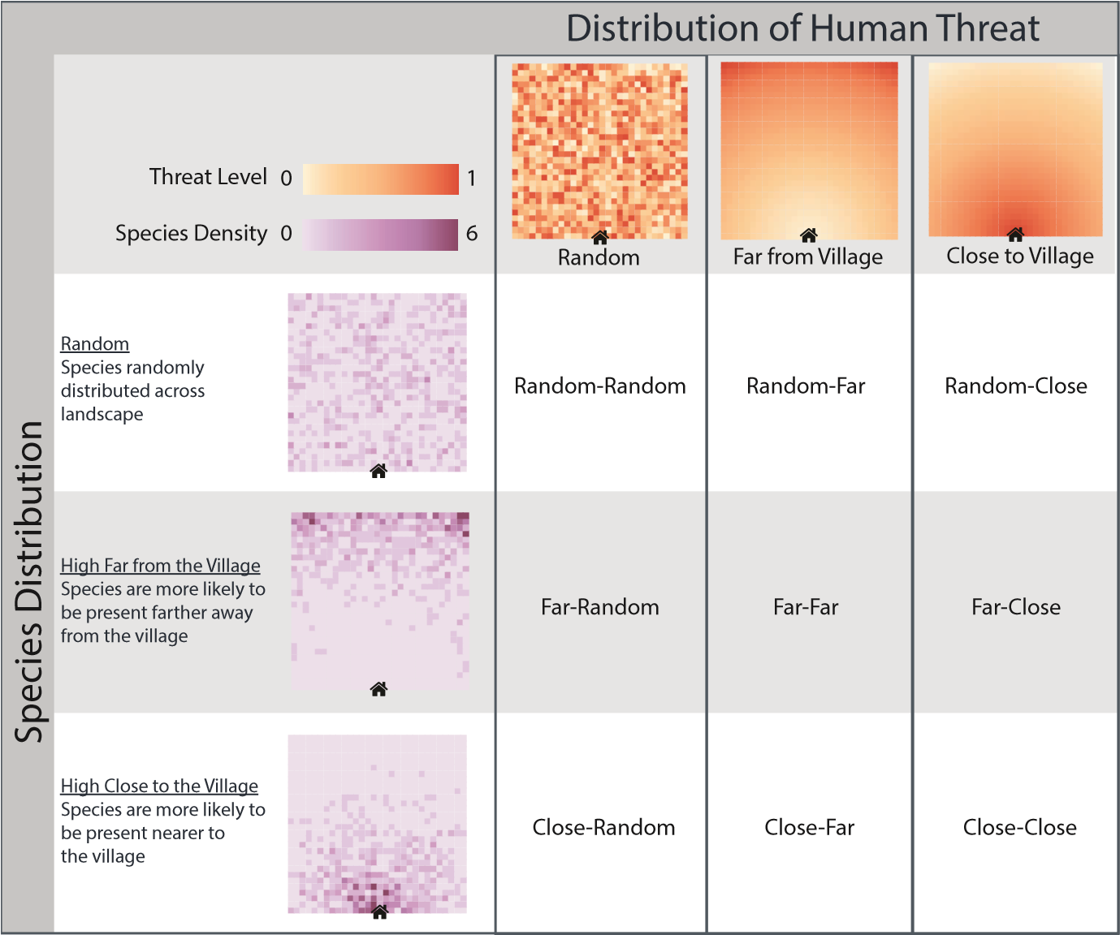

Figure. 1. Stylized Landscapes Vary in the Spatial Distribution of Threat and Species Occurrence.

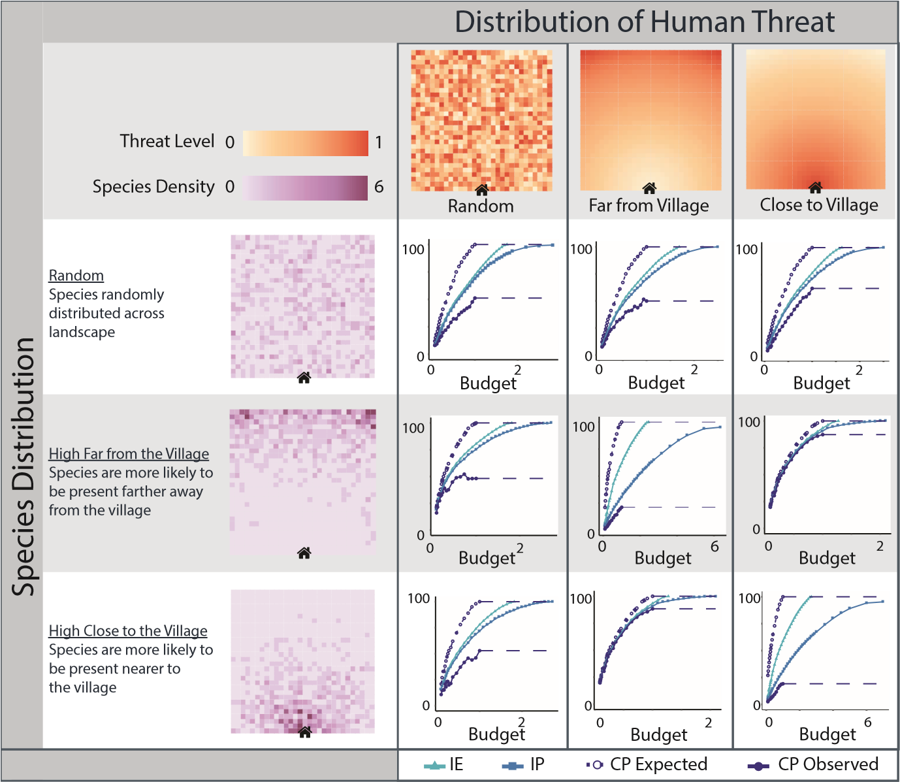

Figure. 2. Results for Stylized Landscapes

Table I. Model Parameters

|  |  |
| --- | --- |
| **Mathematical Variable** | **Simulated Value Range** |
| $$c_{x_{i}}$$ | 30 units |
| $$c_{w_{i}}$$ | Either U(1,60) of 60*linear function of distance to village |
| b | [100,15000] |
| aij | {0,1} in each site for each species; each species distributed in 5% of landscape sites |
| i | 30x30 grid |
| pij | Either an increasing or decreasing linear function of distance to village, p*ij*∈ [0,1] ∀ i,j |
| j | Maximum number of species 100 |

Table II. Protected Area by Country Income

|  |  |  |  |
| --- | --- | --- | --- |
|  | Land Area (sq km) | Protected Area (Percentage) | Protected Area (sq km) |
| High-Income | 35,144,909 | 15.1 | 5,306,881.26 |
| Low and Middle Income | 92,198,311 | 14.6 | 13,460,953.40 |
|  |  | **Total** | **18,767,834.70** |

Table III. Managers’ Spending Per Species

|  |  |  |  |
| --- | --- | --- | --- |
| Scenarios | Informed Enforcer:  Cost per Species | Classic-Purchaser:  Cost per Species | Increase in costs |
| Simulated: Species Far;  Threat Far | 16.94 | 26.44 | 56% |
| Simulated: Species Far;  Threat Random | 12.91 | 21.70 | 68% |
| Simulated: Species Far;  Threat Near | 11.10 | 13.37 | 21% |

The cost per species for the Informed Enforcer is calculated as: [Purchase Cost + Enforcement Cost]/Species. Similarly, the cost per species for Classic Planner is calculated as [Purchase Cost + Enforcement Cost]/Species. The percentage increase in cost associated with the classic planner is calculated as [Cost Per Species for Classic Planner - Cost Per Species for Informed Enforcer]/ Cost Per Species for Informed Enforcer. The calculations are for 90% of the budget at which the classic planner expects to preserve all the species.

**References**

Albers, H., M. Maloney, and E. Robinson (2017). Economics in systematic conservation planning for lower-income countries: A literature review and assessment. International Review of Environmental and Resource Economics 10(2), 145–182.

Ando, A., J. Camm, S. Polasky, and A. Solow (1998). Species distributions, land values, and efficient conservation. Science 279(5359), 2126–2128.

Bravo, H. and S. Theussl (2016). Rcplex: R interface to cplex. [https://CRAN.](https://CRAN.R-project.org/package=Rcplex)

[R-project.org/package=Rcplex.](https://CRAN.R-project.org/package=Rcplex)